**CSC 150 – Program Design Document**

**John Akujobi**

**Structure Chart**

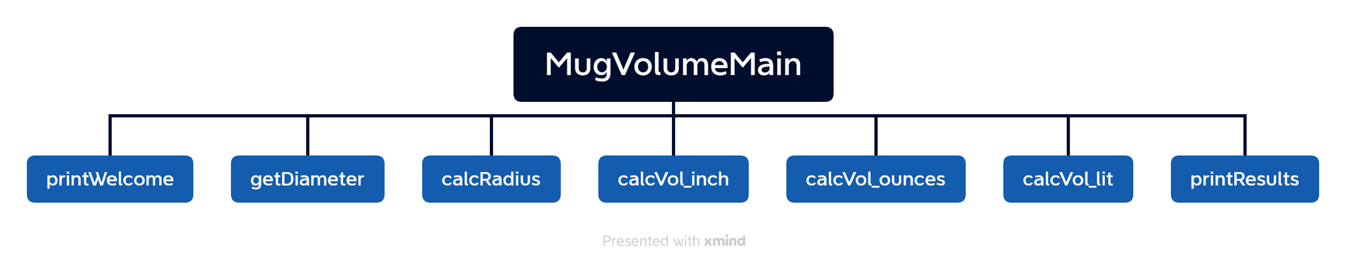

**Data Storage (defined in main)**

//global constants (memory constants are given space in the memory and process more optimally)

const float PI = 3.1416;

const float ToOunces = 0.554113;

const float ToLitres = 0.02841306;

float diameter, volOunces, volLit, radius

**Function Design (for each function, give the function’s prototype and 1 or 2 lines describing how the function works.)**

Add comments on the stuff

//Prints a welcome message to the user

void printWelcome ();

//read diameter from user and return it

float getDiameter();

//divide diameter by 2, to get the radius

float calcRadius (float dia);

//calculate the volume in inch cubes

//divide diameter by 2, use the hemisphere volume formula

float calcVolume_inch (float dia);

//Convert the volume from inch cubes to ounces

//multiply by ToOunces

float calcVolume_ounces (float vol_Inches);

//Convert the volume from inch ounces to litres

//multiply by ToLitres

float calcVolume_lit (float vol_Ounces);

//print the diameter and radius

//volume in inch cubes, ounces and litres

void printResults (float dia, float vol_Ounces, float vol_Inches, float vol_Lit, float rad,);